How to get a Winnipeg Public Library Card

Video Explanation: https://www.youtube.com/watch?v=wR7xAF_FIE4&t=3s

- Go to the Winnipeg Public Library website at wpl.winnipeg.ca (Or search Winnipeg Public Library in search bar in a search engine)
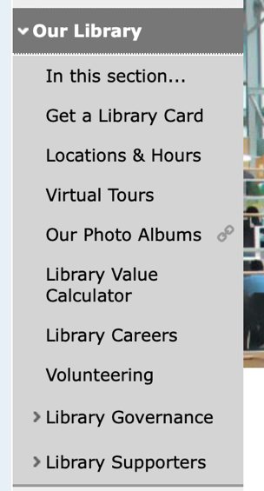
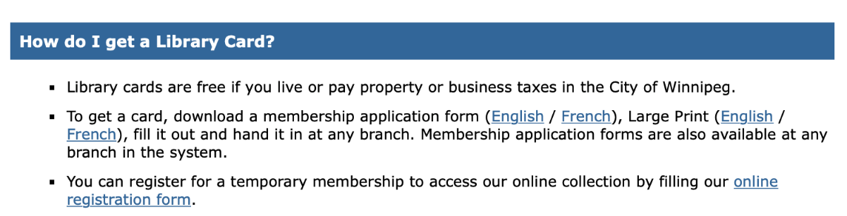
- Go to Our Library Get a Library Card

- Find this and click on the link: You can register for a temporary membership to access our online collection by filling our online registration form

- Fill in the online registration form.

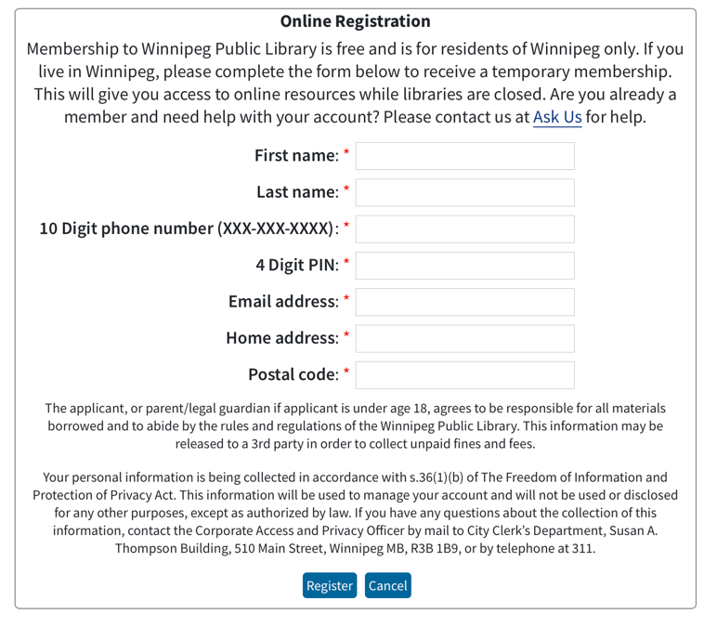

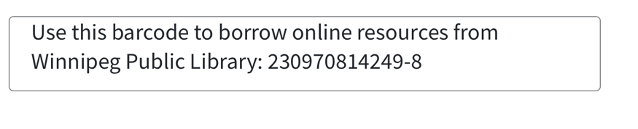
- You will be given a barcode that you can use to borrow online resources. This is your temporary LIBRARY CARD number. Make sure you write it down.
- Go back to Winnipeg Public Library home page wpl.winnipeg.ca

- Go to My Account Log in to my Account
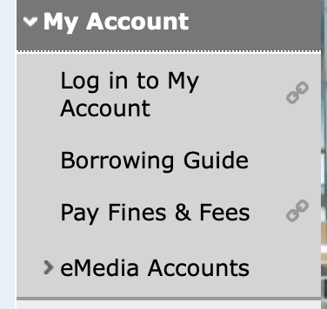

- Enter the Barcode that you were given in the Library Card Number box, and enter the PIN you selected.

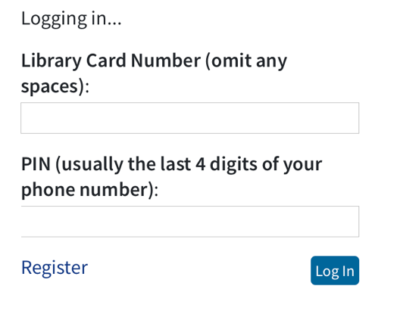

- Browse by format eBooks

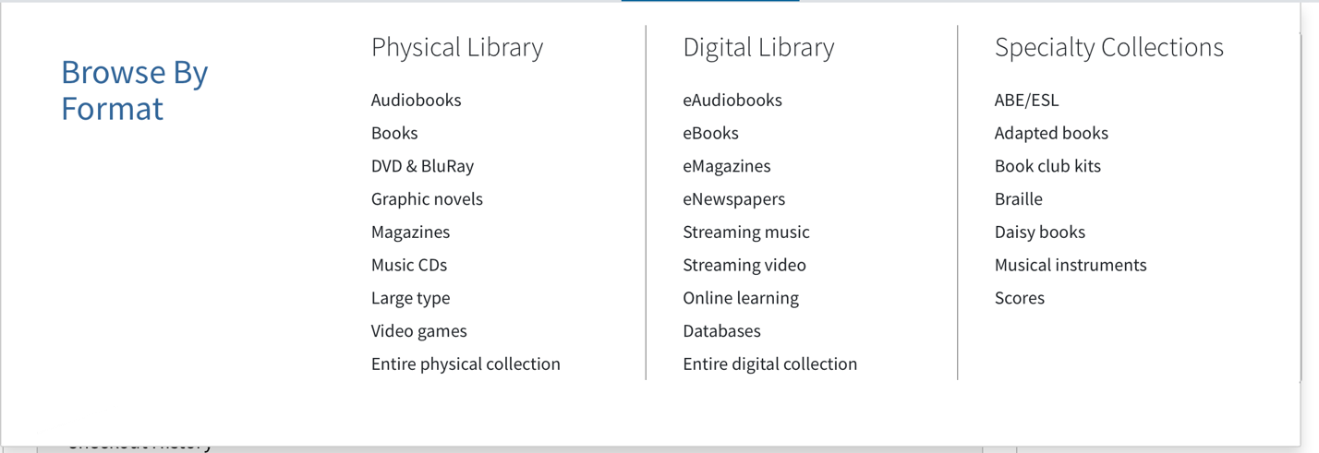

10. Type a book title or an author’s name in the search bar
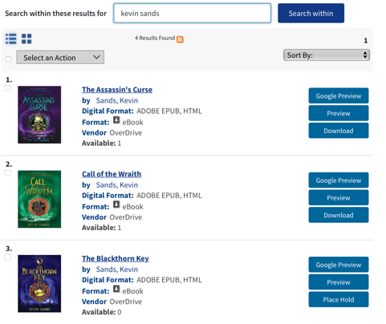

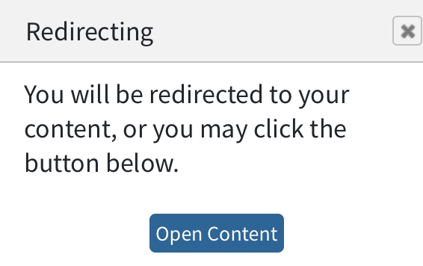
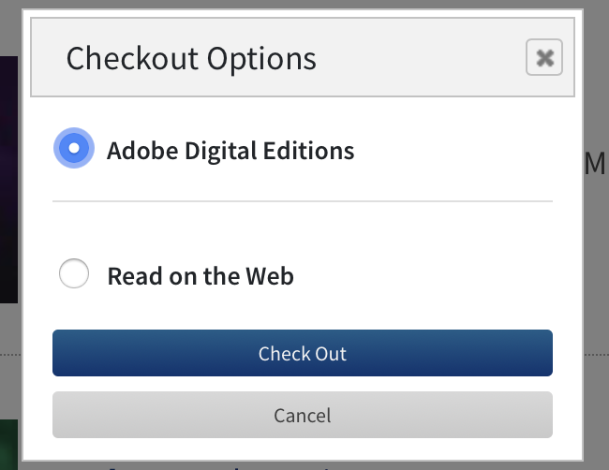
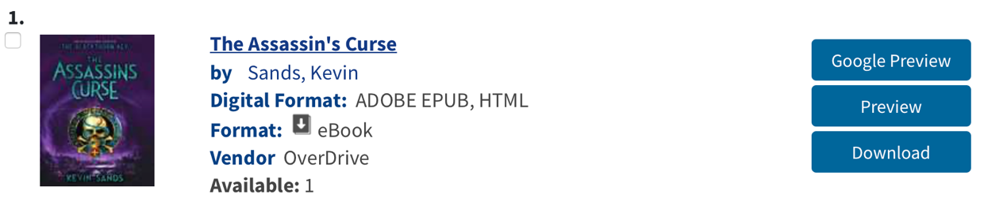
- Click Download Read on Web Check Out Open Content

12. Click My Account to view your checkouts.

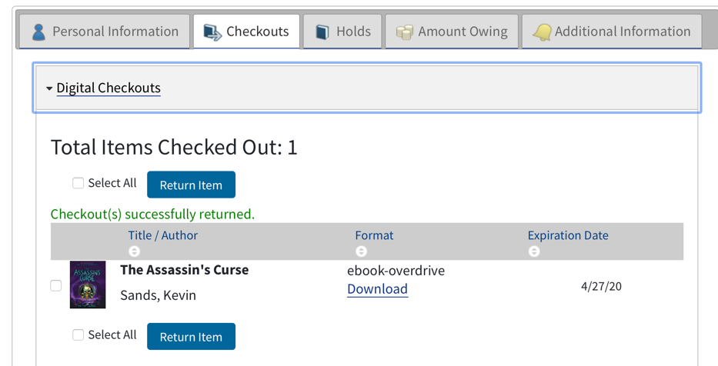

13. Your checkouts will be held for 3 weeks or until you return them.

